1. Writ HTML code to display your biodata consisting of your **PHOTO**, **EDUCATIONAL QUALIFICATIONS** in tabular format**, PERSONAL DETAILS** that include name, age, address, phone no and email and **PROGRAMMING LANGUAGES KNOWN** in list form. Use frames consisting of banner of your name, left frame showing the links to different parts of your biodata.

**Main file**

<html>

**Frame3 file**

<body></body>

<head>

<title>Frames Exercise</title>

</head>

<frameset rows="20%,*">

**Photograph link page**

<html>

<body>

<img

src="profile.jpg"

alt=""

style="width: 100px; height: 100px; margin: 20px; padding: 20px;"

/>

</body>

</html>

<frameset cols="*,*,*">

<frame src="frame1.html" name="frame1">

<frame src="frame2.html" name="frame2">

<frame src="frame3.html" name="frame3">

</frameset>

<frameset cols="50%,*">

<frame src="frame4.html" name="frame4" >

<frame src="frame5.html" name="frame5">

</frameset>

</frameset>

</html>

**Frame1 file**

<html>

<body>

<h1>Chaitanya Chanekar</h1>

</body>

</html>

**Frame2 file**

<html>

<body>

<ul>

<li><a href="photograph.html" target="display">Photograph</a></li>

<li><a href="Detail.html" target="display">Personal Details</a></li>

<li>

<a href="qualification.html" target="display"

>Educational Qualification</a>

</li>

<li>

<a href="pLang.html" target="display">Programming Languages

Known</a>

</li>

</ul>

</body>

</html>

**Details link page**

<html>

<body>

<label for="Name">Name: Chaitanya Chanekar</label> <br />

<label for="age">Age: 18</label> <br />

<label for="Address">Address: Deulwada Parcem Pernem Goa. 403512</label>

<br />

<label for="PhoneNumber">Ph.Number: 987654321</label> <br />

<label for="email">Email: chaitanya.chanekar2292@gmail.com</label> <br />

</body>

</html>

**Qualification link page**

<body>

<h3>Education Qualification</h3>

<ul>

<li>SSC - Fr Agnel High School Pilar</li>

<li>

Diploma in Computer Engineering - Agnel Polytechic Verna. (ongoing)

</li>

</ul>

</body>

</html>

**Programming languages known link page**

<html>

<body>

<h3>Programming Languages</h3>

<ul>

<li>C Language</li>

<li>JAVA</li>

<li>Javascript</li>

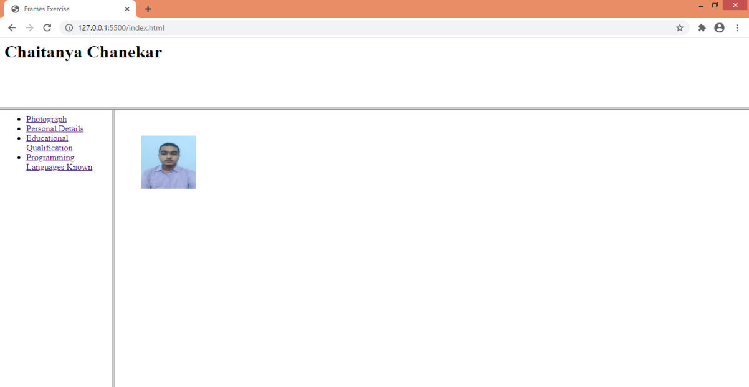 <li>PHP</li>

</ul>

</body>

</html>

**Output:**

